Survey Questionnaire/Results
MUNCH FIND!
━━━━━━━━━━━━━━━━━━━━━━━━━━━━━━━━━━━━━━━━
App Category: Productivity
App Name: MunchFind
App Description: App that solves decision fatigue around food choices. By choosing a random food for the user
Group Members: ***
Date: 29 Jul 2026

1. Google Form link
https://docs.google.com/forms/d/e/1FAIpQLSfkg_ftGVu8mzp7as7IDKW769iamBKTxjtjDQi5TFEPIavMMg/viewform

2. Screenshot of responses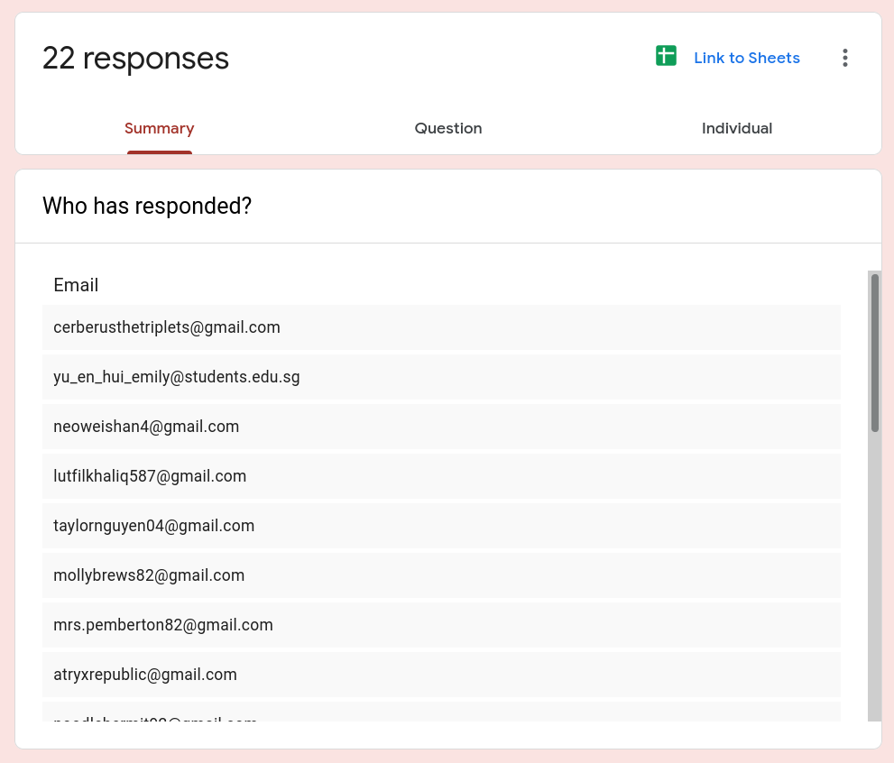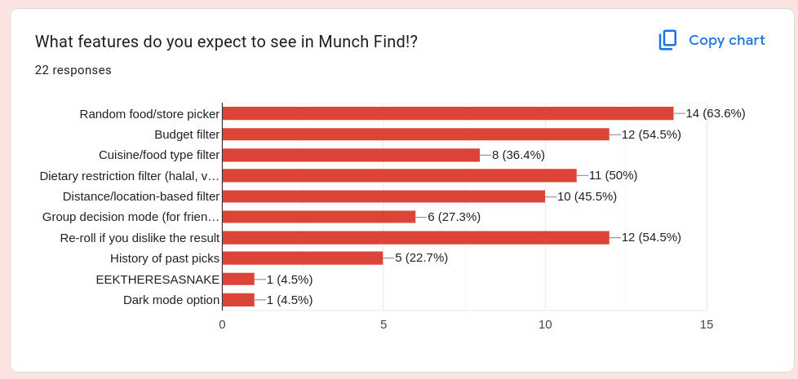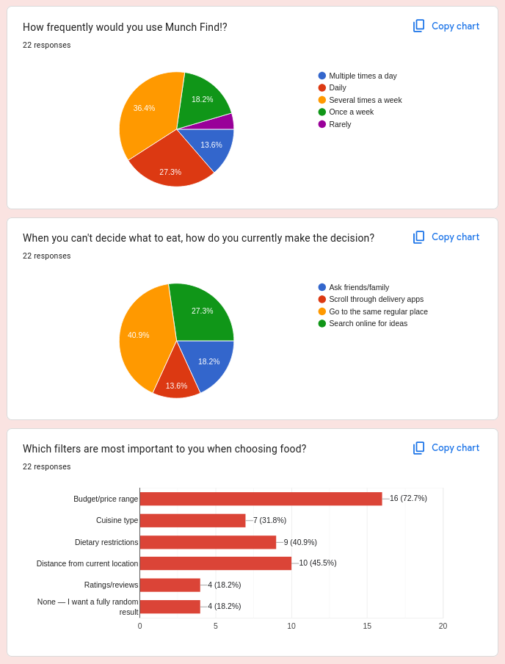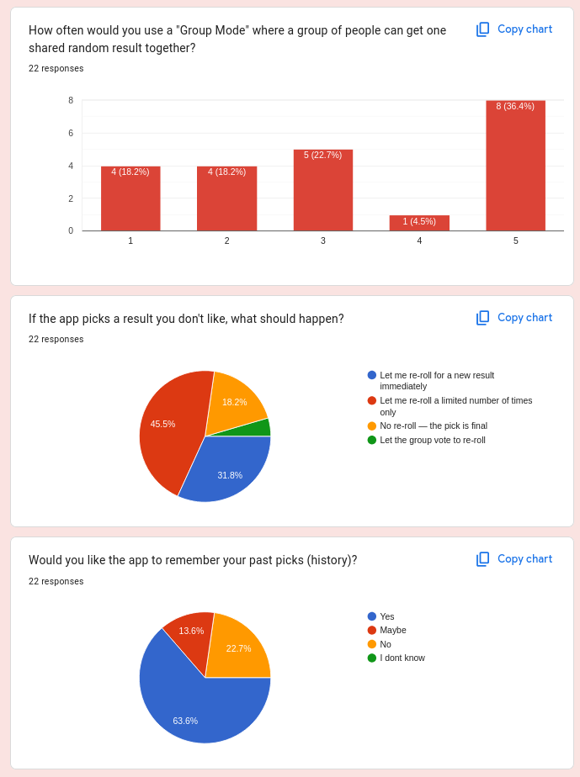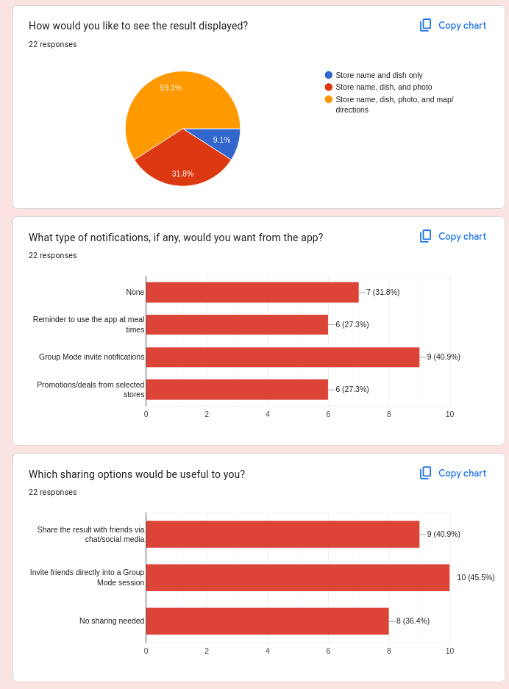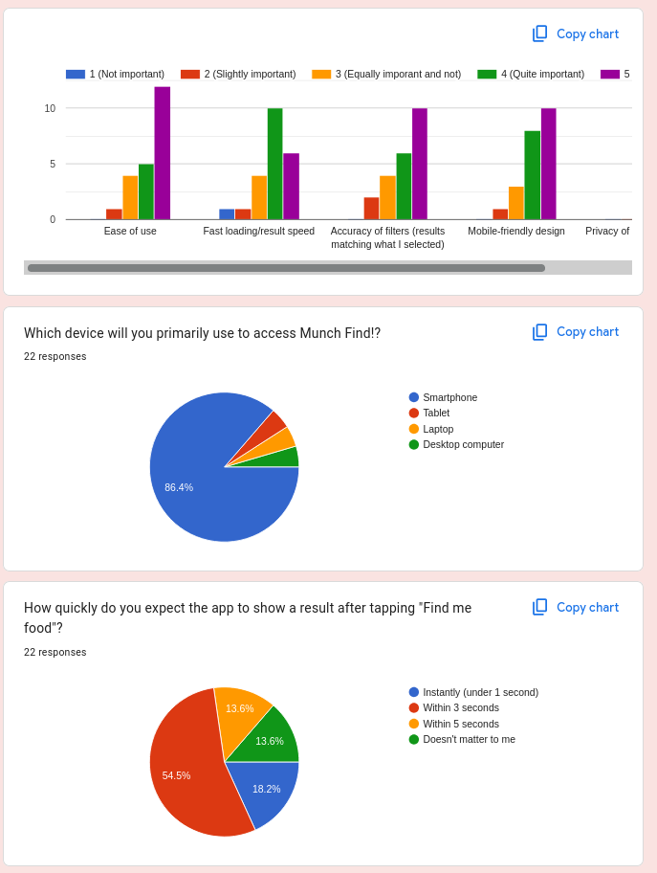

What additional features would you like to suggest for Munch Find!?

13 responses
- Something that accounts for how much actual time I have left on my break. I tell it 15 minutes it should only suggest places I can realistically get to, order from, and get back in time for
- a "budget mode" for splitting group orders would be great. half my group can't agree on price range either. Also, maybe let the app learn what I usually reject over time so the re-rolls get smarter instead of just random again.
- A leaderboard of most-picked restaurants among friends would be fun
- Would love a 'group budget split' calculator feature
- Allergy warnings should be very prominent, not buried in filters
- Not sure I'd use this much honestly
- Show student discounts if available
- Maybe add a 'surprise me' mode that ignores all filters occasionally
- A clean, minimal UI would make me use this more
- Please make sure the halal filter is accurate and verified
- Group voting on the final result before confirming would help

3. Survey analysis summary table

Question | Your Answer
Total number of responses | 22
Most requested feature (Q1) | Random food/store picker (64%), followed by re-roll (55%) and budget filter (55%)
Least requested feature (Q1) | Dark mode option (5%)
How frequently would users use the app? | Most use "Several times a week" or "Daily"
How do users currently decide what to eat? | Most just go to their same regular place; others search online
Most important filters | Budget/price range by far (16/22), then distance and dietary restrictions
Interest in "Group Mode" | Skews high — most rate it 5 (frequent use), average ~3.4/5
What should happen on a disliked result? | Most want a limited number of re-rolls, not unlimited or final
Should the app remember past picks (history)? | Yes — 14/22 want history saved
Preferred result display | Most want store name, dish, photo, AND map/directions
Desired notifications | Group Mode invites top the list, but many want none at all
Useful sharing options | Inviting friends into Group Mode and social/chat sharing both popular
Importance of ease of use | Very important — avg 4.27/5
Importance of fast loading speed | Still important but the relative lowest — avg 3.86/5
Importance of filter accuracy | Very important — avg 4.09/5
Importance of mobile-friendly design | Very important — avg 4.23/5
Importance of location data privacy | Very important — avg 4.05/5
Most used device | Smartphone, by a huge margin (19/22)
Expected result speed | Most expect a result within 3 seconds
Requested features (open-ended) | Group budget-splitting, time-aware suggestions, smarter learning re-rolls, "surprise me" mode, verified halal accuracy, restaurant leaderboard, student discounts, clean UI, group voting before confirming, prominent allergy warnings

